**LAB5: Halftoning**

Mingqin Dai

**I.Motivation**

Halftoning is the process of transforming an image with greater amplitude resolution to one with lesser amplitude resolution. This technique is used to solve image processing problems in printing industry: the solution for displaying continuous tone images with only black and white dots. Halftoning is generated because of the technology gap between image generation and image rendering equipment. This has been practiced for over a hundred years in the printing industry. Halftoning is a technique used in graphics to create the illusion of color depth. In a halftoning image, colors not available in the palette are approximated by a combination of colored pixels from within the available palette. By combining black and white pixels in complex patterns can create the illusion of gray values. And the human eye perceives the diffusion as a mixture of the color within it. We are doing this lab to learn two methods for halftoning, which are dithering matrix and error diffusion.

**II.Method**

*1.All Images*

*(p1)*

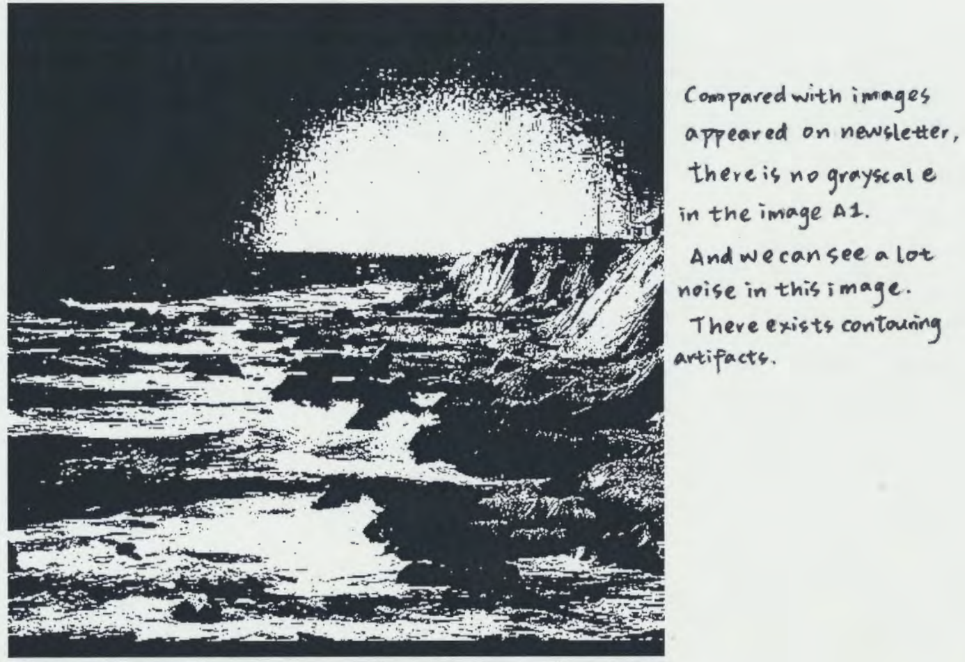

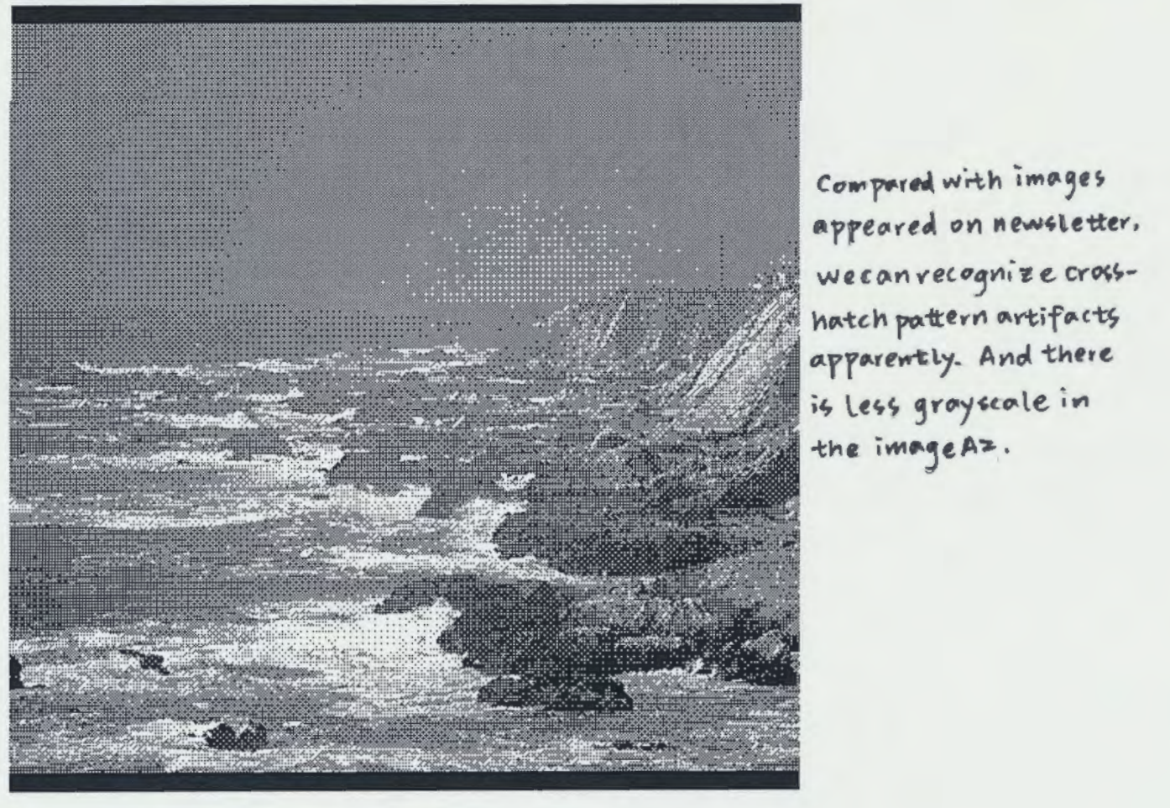

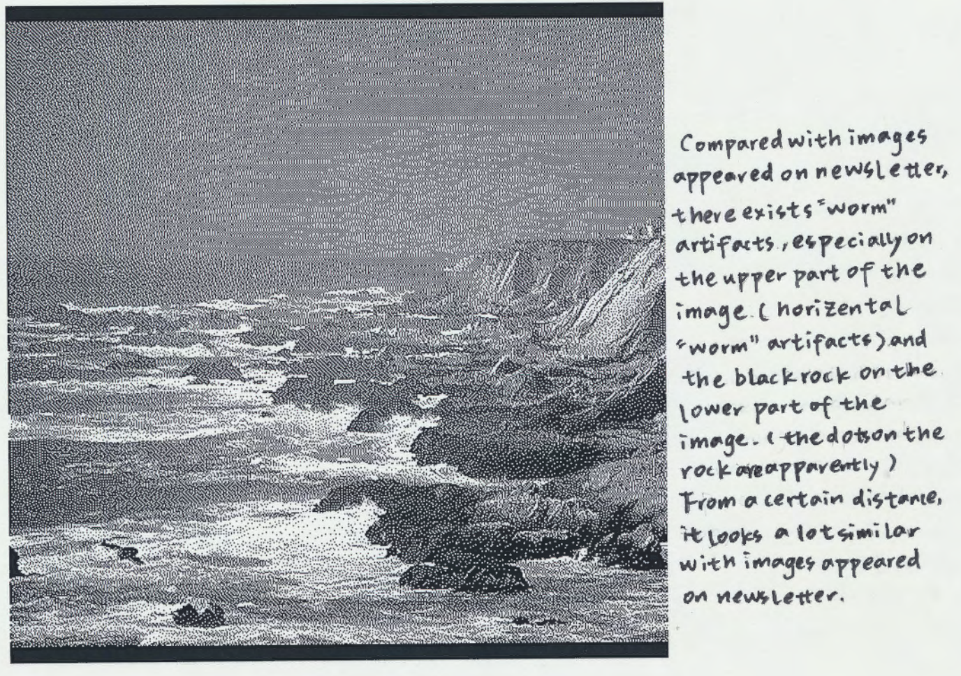

*2.Dithering Matrix*

The dithering matrix method is a halftoning technique where the gray scale values in each local neighborhood of an image are replaced by a set of binary-valued intensities. We use 1x1 subblock and 4x4 subblock in this lab. A better visual approximation could be obtained by using larger subblock. Within each 4x4 subblock we compare each pixel to a fixed threshold taken from a matrix of values. The matrix we used is $\left[\begin{matrix}8 & 136 & 40 & 168 \\ 200 & 72 & 232 & 104 \\ 56 & 184 & 24 & 152 \\ 248 & 120 & 216 & 88\end{matrix}\right]$.

Phenomena which are not present in the source image but produced by the digital signal processing, are called artifacts. significant artifacts like diagonal patterns and the cross-hatch patter artifacts could be easily recognized in the two images. In 1x1 dithering matrix algorithm, we could recognize contouring artifacts easily. However, in 4x4 dithering matrix algorithm, the similarity between adjacent intensity patterns minimizes any contouring artifacts. And in large areas of constant value, the repetitive pattern formed will be mostly artifact-free. (p2)

 Image A2 (4x4 dithering matrix) is perceptually more similar to the original image. Because we could see the edges clearer (it reduce the contouring artifacts mostly). Besides, we could recognize different shades of grey in this image compared with Image A1 that only consisted with white and black. The reasons are as follows. In frequency domain, it retains some of the energy that have been discarded in 1x1 dithering matrix, which might give sharper edges in restored image (spatial domain). The bit depth of this two method are both 1bit. However, the 4x4 dithering matrix could produce 17 different combination of black and white pixels. (the example on the left is 3x3 dithering matrix with 10 different combination of black and white pixels.) From a certain distance or assuming small enough pixels, they look like shades of grey despite being made of only black and white pixels. Thus 4x4 dithering matrix could produce 17 levels of grey shades. On the other hand, the 1x1 dithering matrix could only produce black and white. In human visual perception aspect, dithering images is a technique used in graphics to create the illusion of color depth. In a dithered image, colors not available in the palette are approximated by a combination of colored pixels from within the available palette. The human eye perceives the diffusion as a mixture of the colors within it. And HVS is very sensitive to low frequency noise. (P3)

*3.Error Diffusion*

In image processing, a point process is an operation that uses as its only input the value of the current pixel. A neighborhood process uses a s input the value of the current pixel along with values of pixels surrounding it. One neighborhood process is the error diffusion algorithm. This method attempts to retain image energy by taking into account the amount of energy lost or gained during the quantization of a local neighborhood of pixels. It solves the problem when using a dithering matrix that discards a lot of energy that should have been kept during the quantization process. The binary output signal is subtracted from the pre-threshold signal to form an error. This error is “diffused” into yet to be considered input values as governed by the Error Filter. The signal consisting of past error values is passed through this filter to produce a correction factor to be added to the future input values. The Error Filter we used in this lab is $\left[\begin{matrix}1/16 & 5/16 & 3/16 \\ 7/16 & x & \end{matrix}\right]$, where x is the current pixel location.

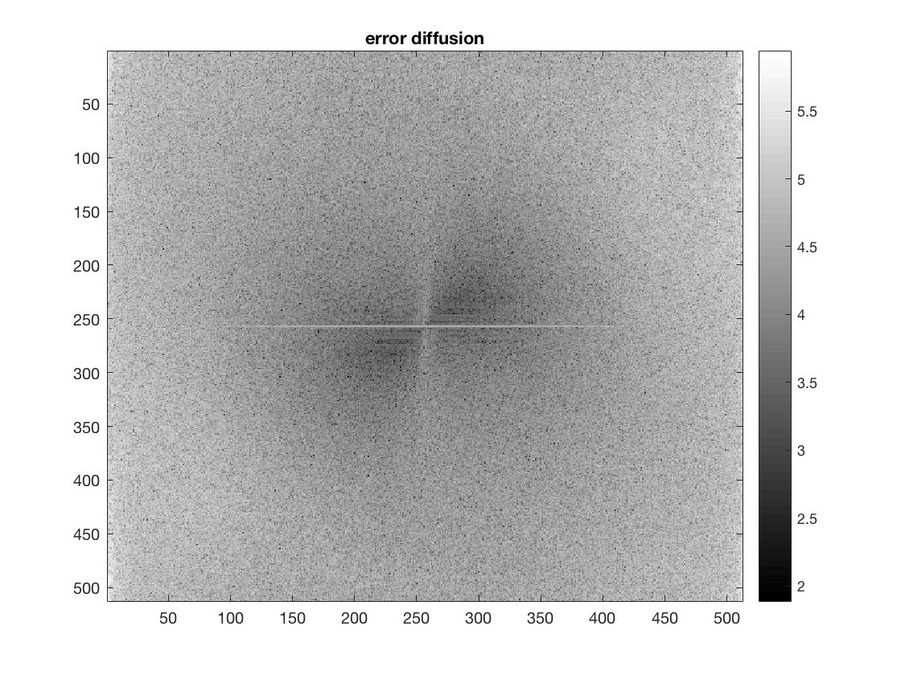We get the energy of errors in the frequency domain by first calculating the two-dimensional Fourier transform of the difference between the original image and error diffusion image, then shifting zero-frequency component to center of spectrum. The filter above is a 2-D nonseparable lowpass filter, then the low-frequency components of the quantization error will be filtered out by the feedback scheme and will not appear on the display. Thus the error diffusion has the tendency to enhance the edges in the original image. In the frequency domain, the edges are represented as high frequency contents. Therefore, similar to the lab 2's result, the error enhances the edges (high frequency domain) and does not desire to display low-frequency content. Another reason for eliminating low-frequency error components is that the Human Visual System is very sensitive to low-frequency noise. Thus it is not desirable to display low frequency error when using error diffusion. (P4)

The mean squared error(MSE) between two images $f\left(x,y\right)$ and $g(x.y)$ is $e_{MSE}=\frac{1}{MN}\sum_{n=1}^{M}{\sum_{m=1}^{N}{[{f\left(n,m\right)-g(n.m)]}^{2}}}$. MSE is a measure of image quality that compare restoration results between original image and restored image. The MSEs are:

1x1 Dithering Matrix (Image A1): $e_{MSE}=9048.77$;

4x4 Dithering Matrix (Image A2): $e_{MSE}=13259.2;$

Error Diffusion (Image B): $e_{MSE}=12873.9$.

Based on my subjective judgement, Image B has the best visual quality, follows by Image A2, and Image A1 has the worst visual quality. Theoretically, lower MSE indicates similar restored image compared with original image. This match with Image A1 and Image B, where lower MSE gives higher visual quality of restored image. However, comparing Image A1 and A2 or Image A1 and Image B, lower MSE actually gives lower visual quality of restored image. This is because perceptually similarity does not mean real similarity. The “perceptually similar” criterion is very important, and is linked to the characteristics of human vision. The human eye perceives the diffusion as a mixture of the colors within it. Thus human eye might recognize the area that made of by complex combination of only black and white pixels as shades of grey. This gives higher visual quality despite the combination of only black and white might actually give higher MSE. (P5)

In terms of minimizing MSE, the 1x1 dithering matrix method with lowest MSE is the best halftoning algorithm theoretically. Because MSE is a measure of image quality that compare restoration results between original image and restored image. Lower MSE indicates higher visual quality. However, considering frequency domain, this algorithm discards a lot of energy that should have been kept during the quantization process. Perceptually, error diffusion algorithm gives higher quality of the restored image. Though it suffers from directional “worm” artifacts, it minimizes the cross-hatch pattern artifacts which produced through dithering matrix algorithm. Error diffusion algorithm makes the edges clearer by reducing lower frequency error, which makes the image much easier in recognition. The lowest attainable MSE for the image I used is $e_{MSE}=9048.77$ (1x1 Dithering Matrix (Image A1)). (P6)

**III.Conclusion**

The main difference between the two halftoning method is that error diffusion algorithm attempts to retain image energy by taking into account the amount of energy lost or gained during the quantization of a local neighborhood of pixels. It solves the problem when using a dithering matrix that discards a lot of energy that should have been kept during the quantization process. The goal of all halftoning techniques is to generate an image with fewer amplitude levels that is perceptually similar to the original. Unfortunately, the regularity of these algorithms leads to different kinds of artifacts which detracts from the rendered image. The dither matrix algorithm is in very common use and is easily identified by the cross-hatch pattern artifacts it produces in the resulting display. And the error diffusion algorithm produces the clustering artifacts. However, error diffusion generates the best results of any of the digital halftoning methods described here. Much of the low-frequency noise component is suppressed, producing images with very little grain. From a certain distance or assuming small enough pixels, they look like shades of grey despite being made of only black and white pixels.